GP Track Record Analyzer
User Manual — for UNJSPF OIM Investment Analysts
Version 1.0 · August 2026 · covers download, setup, and the full analysis workflow

1. What this tool does
Every GP submits its track record in a different Excel format — different column names, layouts, units, footnotes. The analysis we want at the end is always the same: the standardized 7-tab Segmented Track Record Analysis workbook. This tool automates everything in between, so the hours you would spend re-keying and reconciling a GP's spreadsheet go into actually evaluating the manager.
The whole journey: GP's raw Excel file → web app (parse + review the mapping) → standardized Deal Level Input file → one macro in Excel → 7 analysis tabs. Verified deals can then be published to the team's deal database for Power BI.
Everything runs locally on your own computer. GP data never leaves it.

2. What you need
- Microsoft Excel (Windows or Mac) able to run macros.
- Python 3.10 or newer — free from python.org (Section 4 walks through it).
- Internet access once, for the first-time setup. After that the app works offline.

3. Getting the tool
- Open the team's private GitHub repository and switch the branch selector (top-left) to vba.
https://github.com/jjjane-wu/Track-Record-Analyzer/tree/vba
- Click the green Code button → Download ZIP. (Or ask the maintainer for the ZIP directly.)
- Windows only, before extracting: right-click the downloaded ZIP → Properties → tick Unblock → OK. This clears Windows' "downloaded from the internet" flag; skipping it is the #1 reason Excel later refuses to run the macros.
- Extract the ZIP anywhere you like — Desktop, Documents and OneDrive folders are all fine.

What's in the folder
start.bat / start.command — double-click launcher (Windows / Mac)
vba/TR-Analyzer.xlsm — the Excel analyzer (macros only; it ships empty)
User Guide.md, README.md — the same guidance in text form

4. One-time setup (per computer)
- Install Python from https://www.python.org/downloads/. Windows: on the very first installer screen, tick “Add python.exe to PATH”.
- Double-click the launcher: start.bat on Windows, start.command on Mac.
- The first run creates the app's private environment and installs its components — a few minutes, once. Afterwards the app starts in seconds.
- Your browser opens the app automatically. Keep the launcher window open while you work; close it to stop the app.

If setup fails
Most common cause: the office network blocks Python package downloads. Screenshot the launcher window and send it to the maintainer — IT can allow pypi.org.
Windows SmartScreen may warn about the launcher: click More info → Run anyway.

5. The everyday workflow

Step 1 — Upload the GP's raw file
Drag the GP's Excel file into the upload box. The app scans the workbook immediately and shows what it found: the deal table it detected, the GP name (from the filename — correct it if wrong), and your name. Usually you touch nothing here. Click Parse File →.
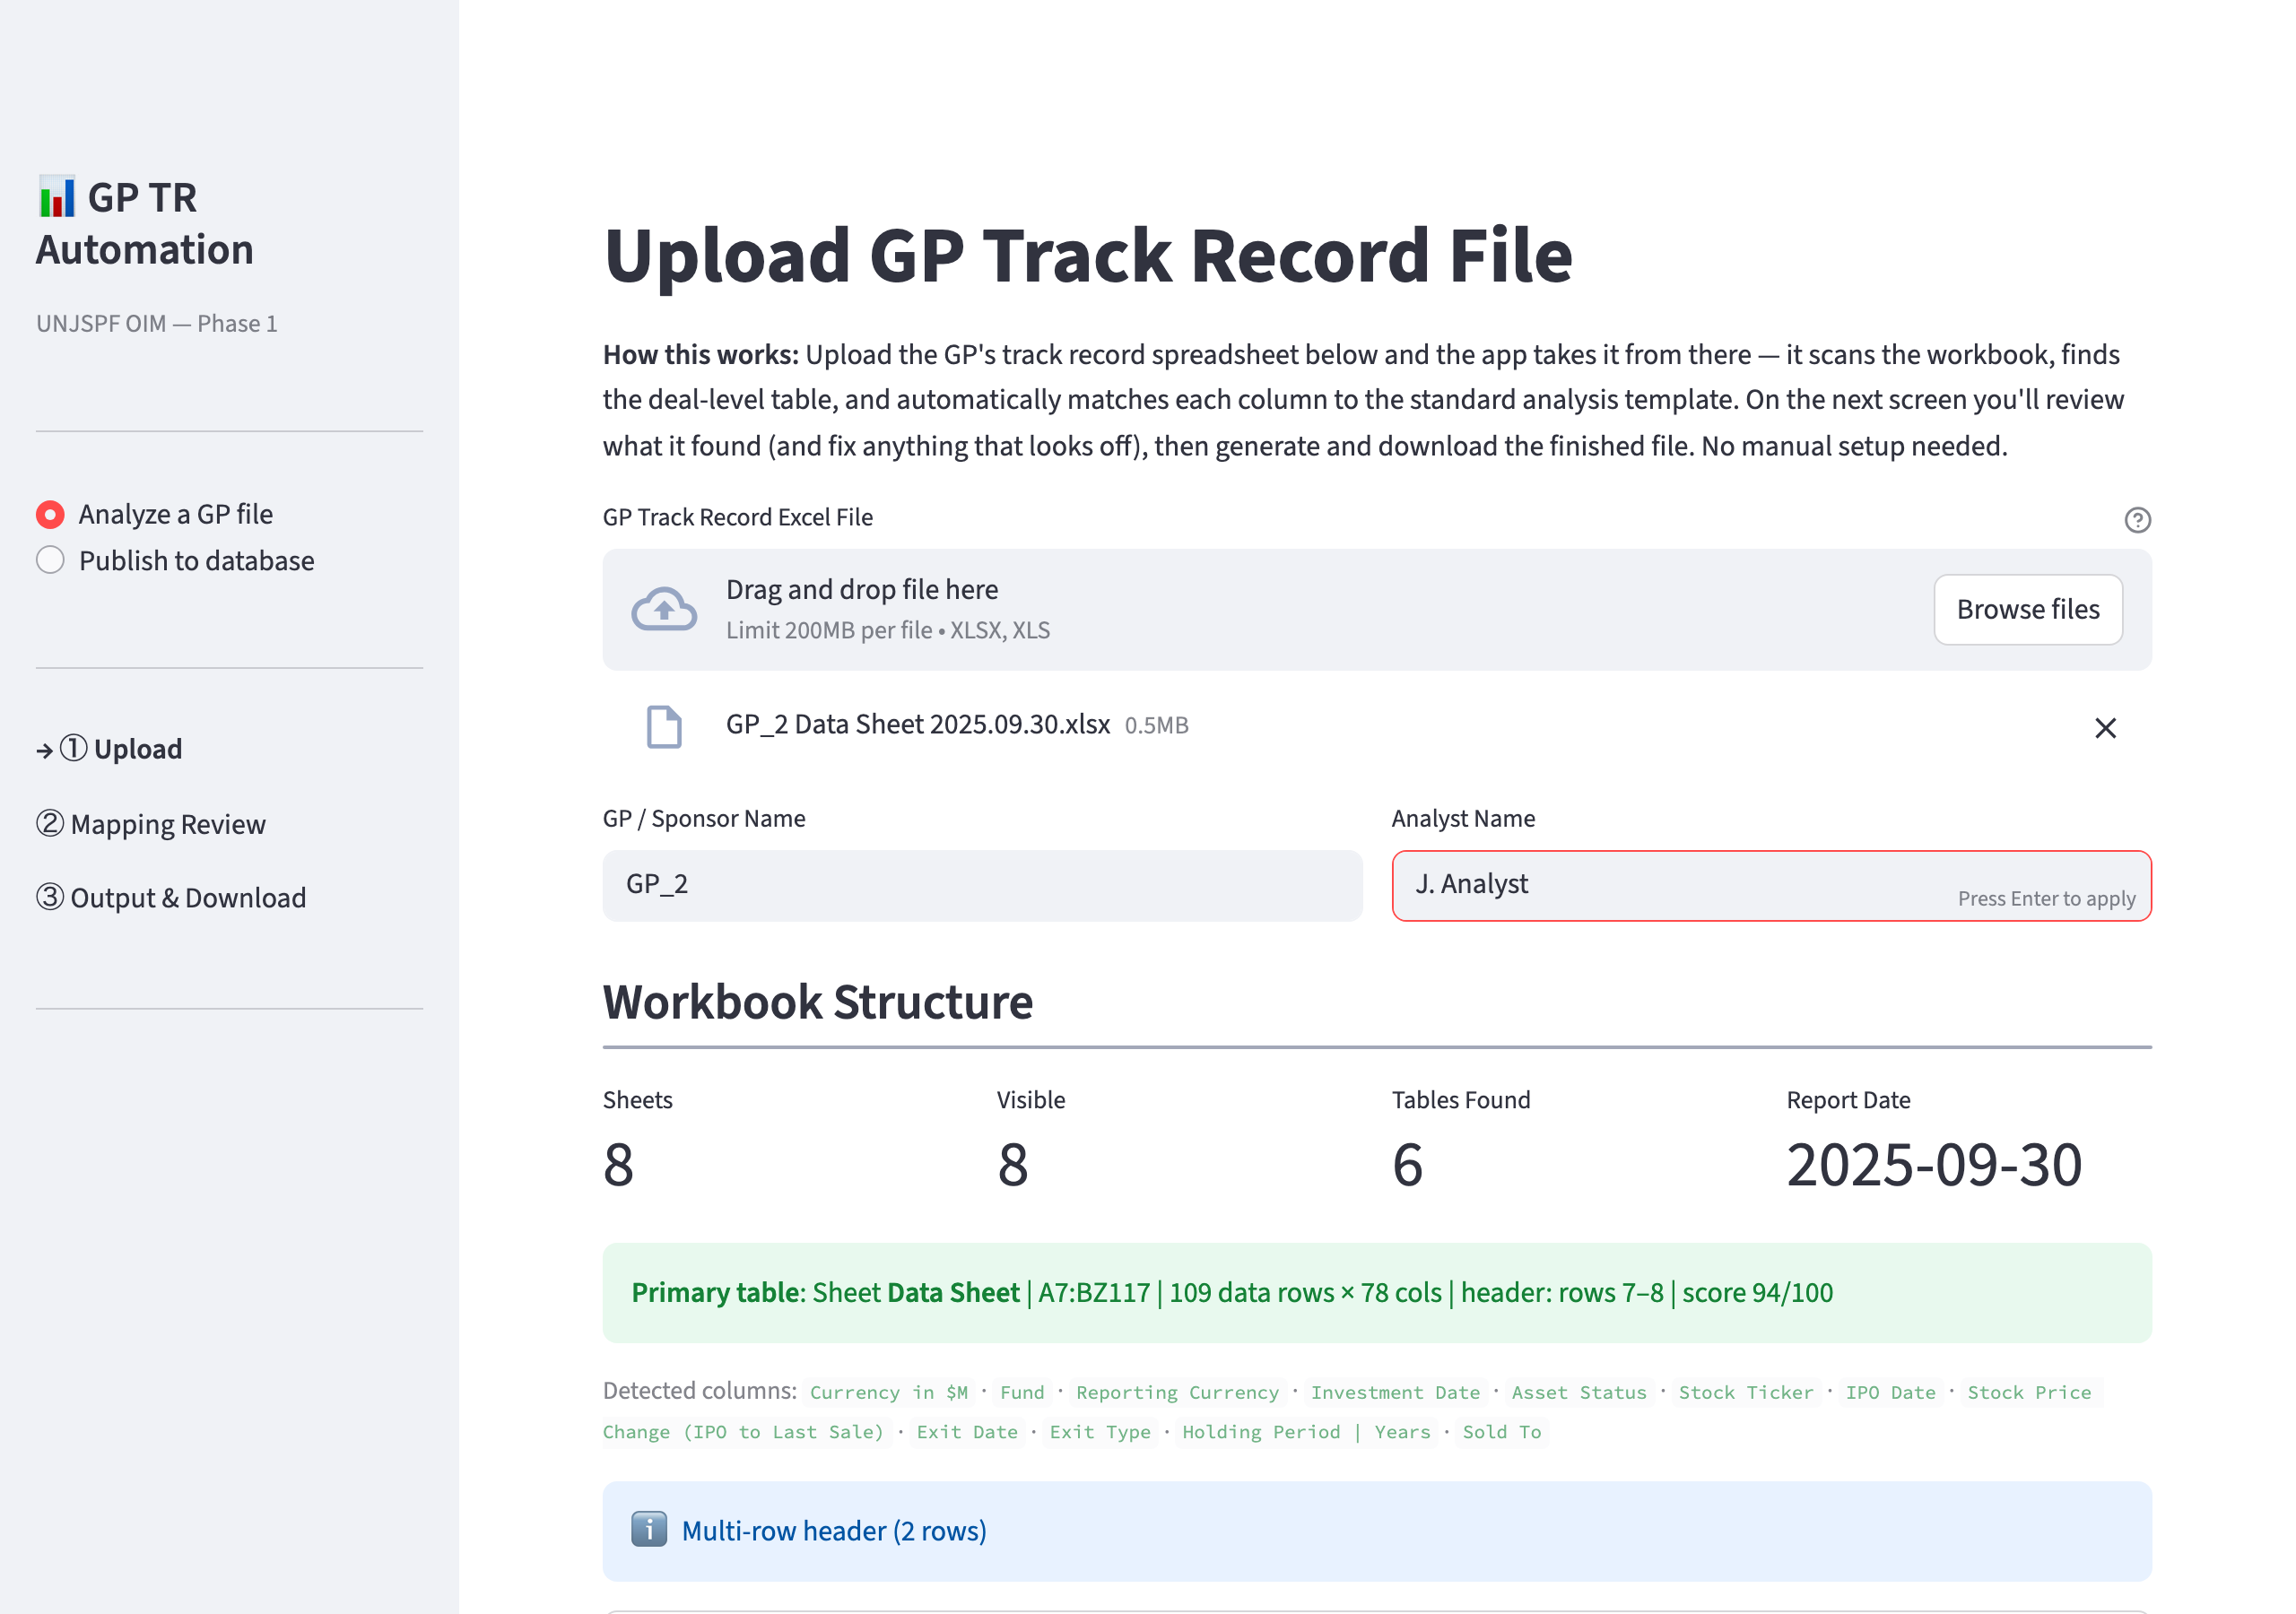
Screen 1 — the raw file uploaded and profiled; the detected deal table is highlighted.
A few seconds later the app lists every fund it detected — all funds are included automatically. To look at a subset later, use the Fund filter that every pivot in the analysis carries.

Step 2 — Review the column mapping (the one step that needs your judgment)
The app has matched the GP's messy headers to our 33 standard fields, showing its reasoning and a confidence score for each. Yellow rows are probable matches — glance at each; if one is wrong, pick the right source column from its dropdown. Red / unmapped fields simply stay blank if the data isn't in the file. Validation warnings below flag oddities in the GP's own numbers (exit before entry, IRR that looks like percentage points) — keep them for the diligence call. Then click Generate Analysis →.
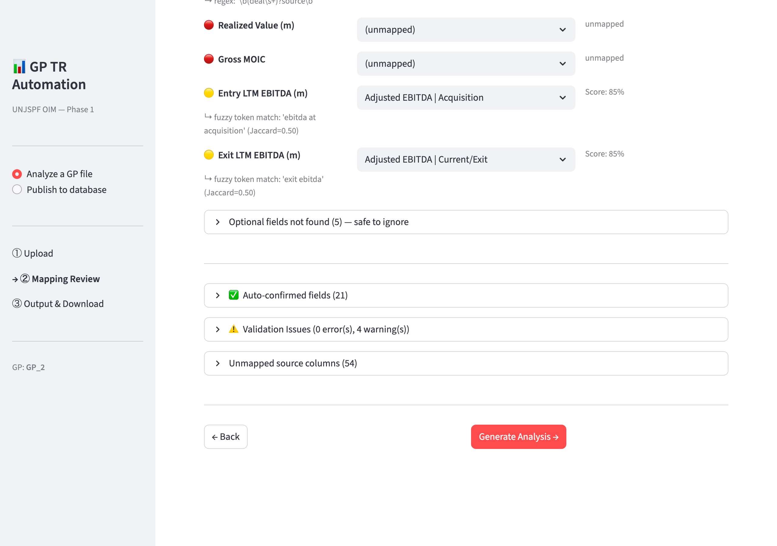
Screen 2 — confidence-coded mapping review; fix any miss with a dropdown.
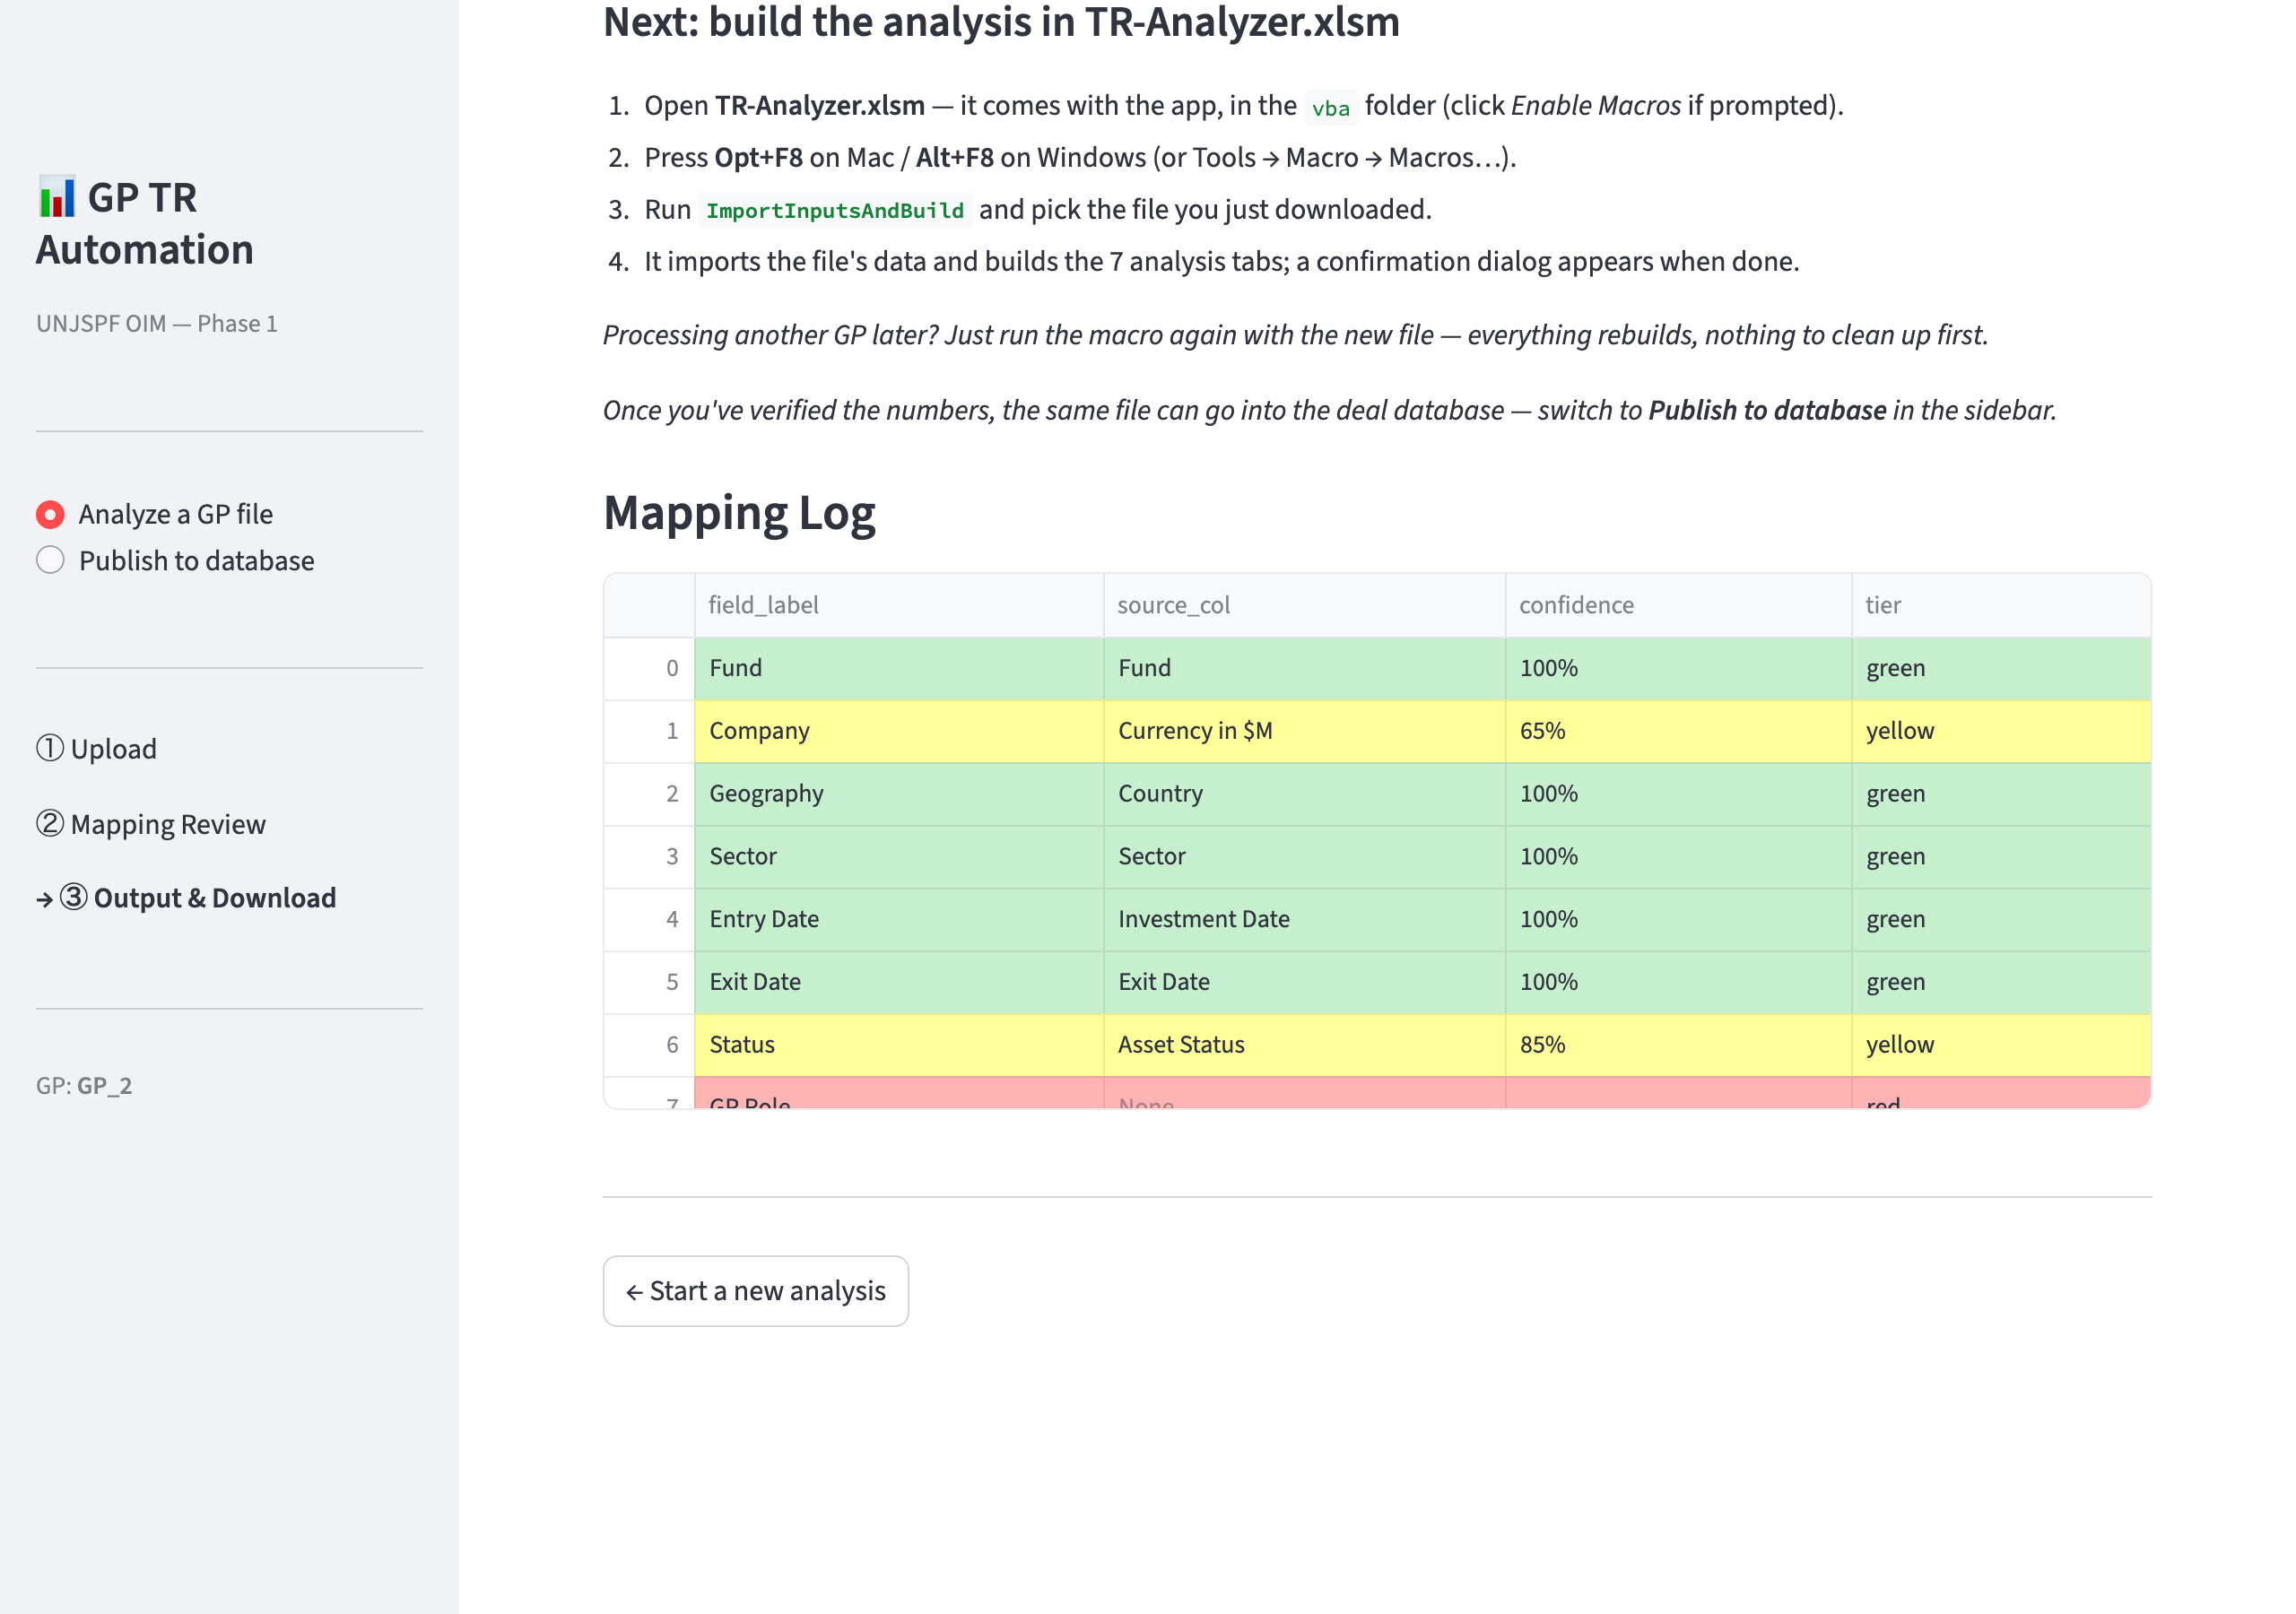
Screen 3 — summary metrics and the Deal Level Input download.
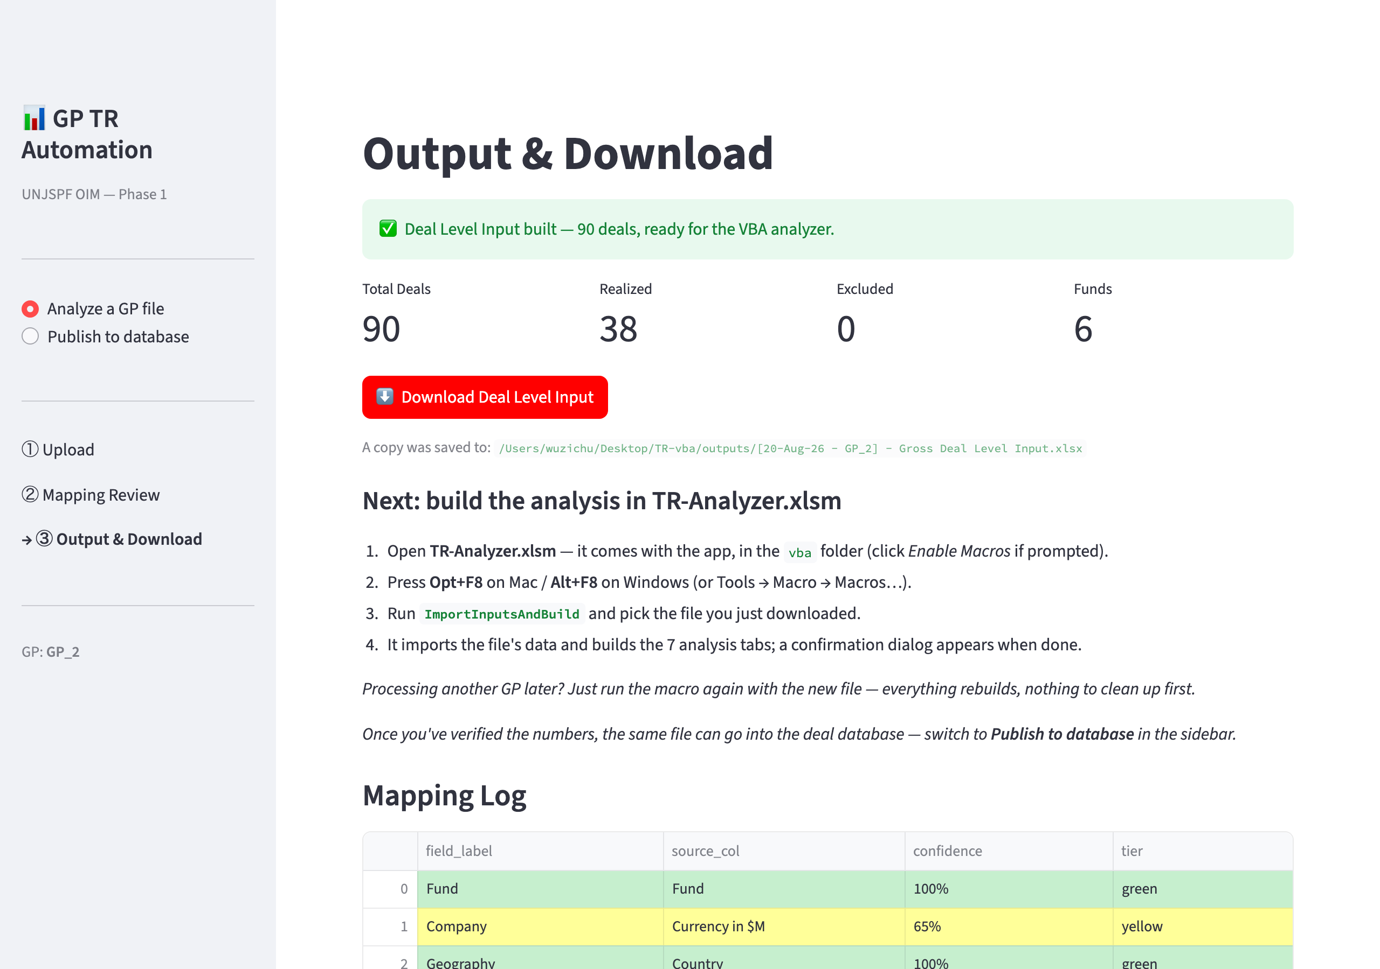
The same steps are shown in the app after every download.

Step 3 — Download the Deal Level Input
The app builds the standardized hand-off file and shows the headline numbers. Click ⬇ Download Deal Level Input — you get [date - GP] - Gross Deal Level Input.xlsx (a backup copy is also saved to the app's outputs folder). If anything looks off, click ← Back, fix the mapping, and download again — it takes seconds.

Step 4 — Build the analysis in Excel (one macro)
- Open vba/TR-Analyzer.xlsm from the tool folder. When Excel asks, click Enable Macros.
- Press Alt+F8 (Windows) / Opt+F8 (Mac), select ImportInputsAndBuild, click Run.
- In the file dialog, pick the Deal Level Input file you just downloaded.
- About one second later all 7 analysis tabs are built. The instructions page disappears with the build — that's by design.

Two things worth knowing
Picked the wrong file? If you select something that isn't a Deal Level Input workbook (for example the GP's raw file), the macro tells you so in plain words and stops — nothing breaks. Pick the file whose name contains “Gross Deal Level Input”.
Save your work under its own name (File → Save As, e.g. GP_2 - Analysis.xlsm) so the original analyzer stays empty and ready for the next GP.

What you get — the 7 tabs
The workbook opens on a Table of Contents; every entry is a clickable link with a one-line description of its tab:
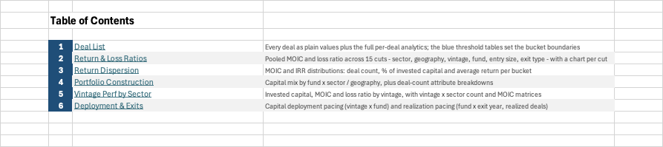
Table of Contents — numbered links plus what each tab shows.
The Deal List holds every deal as plain values plus the full per-deal analytics. The light-blue threshold tables at the top set every bucket boundary — edit a threshold and the whole workbook re-buckets instantly:
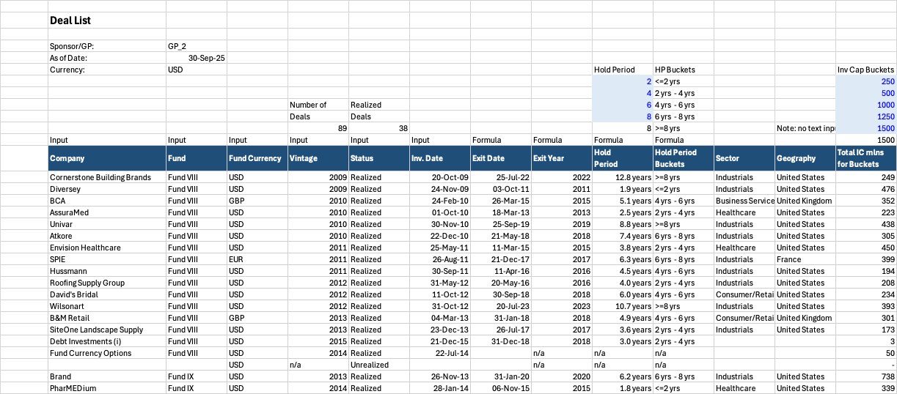
Deal List — imported deals, per-deal analytics, editable bucket thresholds (blue).
The five analysis tabs slice the portfolio with native pivot tables — for example Return & Loss Ratios, which pools MOIC and loss ratio across fifteen cuts:
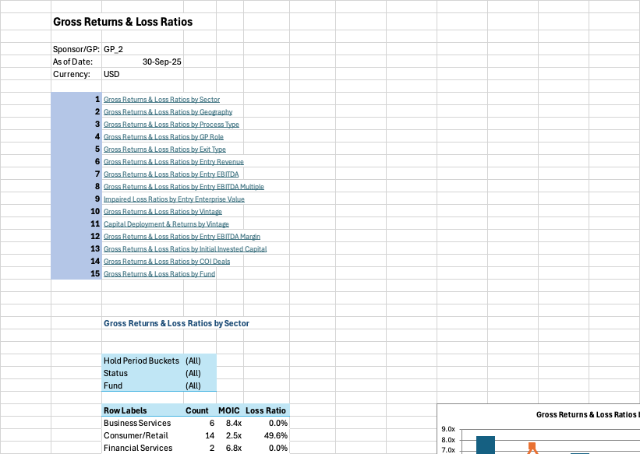
Return & Loss Ratios — one of fifteen cuts, each with its own chart.
- Blue = type here. White = calculated. Grey = key result.
- Every pivot carries Fund / Status / Hold-Period filters. Setting Status = Realized is the acid test — the track record in cash terms, the GP's own marks stripped out.
- Charts never change — they are fixed snapshots of the full portfolio (blank / n/a categories are left off). The pivots are for exploring.
- Deals missing a label are hidden from that pivot and its totals; nothing is deleted — un-hide via the filter dropdown.

6. Publishing to the deal database (optional, after verification)
Verified deals feed the team's cross-GP database — the pool behind the Power BI dashboard. This is deliberately a separate, manual step: nothing enters the database until a person has checked the numbers. First correct and verify the Deal Level Input in Excel; then switch the app's sidebar to Publish to database and upload that file.
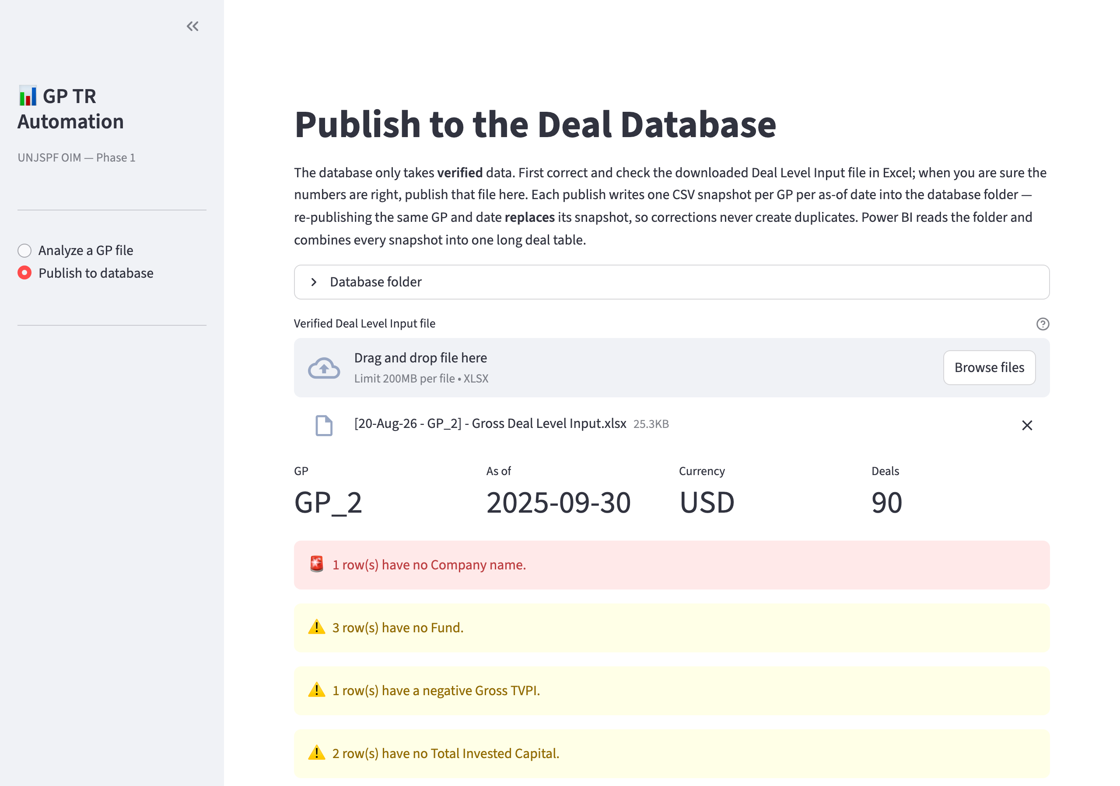
The publish gate at work — hard errors block publishing until fixed in Excel; soft warnings need an explicit tick.
On Publish, one CSV snapshot is written per GP per as-of date. Re-publishing the same GP and date replaces its snapshot — corrections never duplicate. Once the database folder points at the team's OneDrive-synced SharePoint library, every publish uploads itself and Power BI picks it up on its next refresh.

7. Troubleshooting
Symptom | What to do
Excel won't run the macros / no Enable Macros prompt | The ZIP was extracted without unblocking (Windows). Delete the folder, right-click the ZIP → Properties → Unblock → OK, extract again.
“…doesn't look like a Deal Level Input workbook” message | You picked the wrong file in the macro's dialog — usually the GP's raw spreadsheet. Pick the downloaded file whose name contains “Gross Deal Level Input”.
A VBA error dialog with End / Debug buttons | Click End (never Debug), then tell the maintainer what you were doing. Debug leaves Excel in a stuck state.
Launcher window closes immediately or shows errors | Screenshot it and send it to the maintainer. Usual cause: the network blocks pypi.org (IT can allow it).
Browser didn't open | Open it yourself and go to http://localhost:8501 while the launcher window is running.
The app says the mapping missed a field | That's normal for optional fields the GP doesn't report — they stay blank. Only fix mappings for data that is actually in the file.

8. Quick reference
1 Double-click start.bat / start.command — the app opens in your browser.
2 Screen 1: drag in the GP's raw file → Parse.
3 Screen 2: review the yellow mappings → Generate.
4 Screen 3: Download Deal Level Input.
5 vba/TR-Analyzer.xlsm → Enable Macros → Alt/Opt+F8 → ImportInputsAndBuild → pick the download → 7 tabs. Save As its own name.
6 (After verifying) sidebar → Publish to database → upload the verified file → Publish.

